

CAF Adopt Phase - Scenario 3 - SQL Migration - On Prem to Azure Managed Instance

List of Contents
1. Adopt (Migration) 3
1.1 Overview 3
1.1.1 Assess Workloads 3
1.1.2 Deploy workloads 3
1.1.3 Release Workloads 3
1.2 Assessment 6
1.2.1 Region 7
1.2.2 Migration Toolset 8
1.3 Deployment 9
1.3.1 Azure Migration Service 9
1.3.2 Native RESTORE from URL 9
1.4 Release 11
1.4.1 Overview 11
1.4.2 Migration Testing 11
1.4.3 Optimization 15
1.4.4 Additional Post Migration Validation and Optimization Documents 17
1.5 Additional Resources 17

Adopt (Migration)
Before the beginning of data migration to the cloud, the following assumptions should be made.
- From the Plan, Ready, and Adopt methodologies, the source data should have been identified and separated into workloads which are manageable to migrate through iterations.
- There should be a landing zone prepared with the adequate configurations to receive the incoming data workloads
SQL Managed Instance has characteristics and resource limits that depend on the underlying infrastructure and architecture. SQL Managed Instance can be deployed on two hardware generations: Gen4 and Gen5.

Below Link explains detail resource limit for SQL managed instance
https://docs.microsoft.com/en-us/azure/azure-sql/managed-instance/resource-limits

SQL Server on Azure SQL Managed Instance supports migration of the following versions of the SQL Serve:
- SQL Server 2005
- SQL Server 2008 and SQL Server 2008 R2
- SQL Server 2012 and SQL Server 2012 SP1 CU2
- SQL Server 2014
- SQL Server 2016
- SQL Server 2017

Overview
During each iteration of migrating a workload, there are 3 phases which are necessary to maximize performance. This section will specifically discuss the following:
- Assess workloads
- Deploy workloads
- Release workloads

Assess Workloads
Make concrete decisions regarding cost, modernization options, and deployment tools. Reassure that any assumptions made during the discovery phase on the data characteristics holds to be true; as well as build on top of those decisions to give the most redefined description about that data.

Deploy Workloads
Replicate or improve performance from the source by taking advantage of tools available in the cloud such as:
- Azure Database Migration Services
- Data Migration Assistant

Release Workloads
Once the data workloads has been deployed in the cloud, testing, optimization, and review of the newly deployed workload should be done to ensure the correct data and functionality has been deployed.

Below steps will walk us through the overview of the migration process.
- Consider the maintenance windows that are available to the application and database targeted for migration: If they are critical workloads, they may only be able to go offline for a few minutes at a very specific point in time. Alternatively, a workload may be used for historical reporting purposes and can easily be taken offline most days of the week without impacting end-users. These differences will help decide which migration technique needs to be used.
- Start with low priority databases first: This can help ensure the migration process works and help gauge how long the migration is likely to take when you get to your more critical workloads.
- Fix compatibility issues outlined in Data Migration Assistant: These issues should be fixed during the Transform and Optimize phase, but validate that DMA no longer presents any remaining issues.
- Run a test migration with chosen tool: Before migrating the database, run a test migration of the database to confirm the amount of time the migration will take, and any issues encountered during the migration process.
- Test database for issues: When the test migration completes, perform validation steps to confirm that the data is migrated in full and check for any issues encountered on the Azure SQL platform.
- Repeat issue fixes until the database is fixed: For each issue discovered during testing, find a fix, and then retest. Keep repeating this test-fix cycle until all issues have been found and repaired.
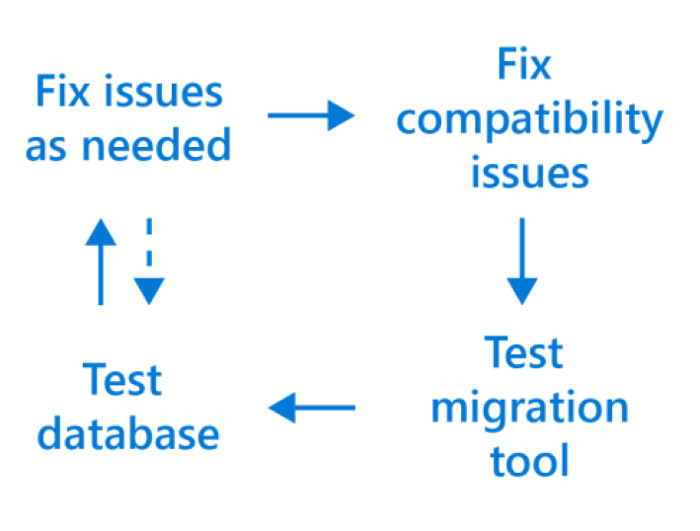
- Re-write third-party applications for the cloud as needed: Third party applications may benefit from the Azure Application Architecture Guide as it discusses older on premises versus cloud architecture models that could help optimize performance and decrease overhead with leaner coding approaches. Each application should be analyzed on a case by case basis to see if a lift and shift or a re-write in necessary.
- Test third-party applications: Confirm that any third-party applications will still function as expected in the cloud as each application is moved, including any dependencies.
- Take old databases and application offline: Remember to take the source database and application offline before starting the migration process to avoid confusion and preserve the original data in case there is a need to refer to them or perform a roll-back.
- Create new disaster recovery and maintenance plans: Take the time to update your disaster recovery plans, as data has now moved locations and is accessed in a different manner. Consider improving disaster recovery plans by utilizing the geo-replication features of Azure to protect data that may previously have been too complex or costly to protect when on-premises. Maintenance plans will also need to be reviewed as Azure now performs many of those maintenance tasks automatically for you in the background, removing the need to perform them manually.
- Use toolsets to give you greater insight into your environment and greatly assist with the migration process: Numerous Microsoft and third-party tools exist that can help keep tabs on your SQL environments both on premises and in the cloud, including:
- Azure Database Migration Service (DMS) helps track progress of large-scale migrations of data to Azure.
- Microsoft Operations Management Suite can help monitor and visualize SQL workloads both on-premises and in the cloud, including SQL Server version count, current CPU performance, job successes and failures, and any logged events.
- Azure SQL Database Intelligent Insights is a tool that uses built-in intelligence to continuously monitor database usage and detect disruptive events that cause poor performance, offering recommendations for improvements that could help with functionality.
- Assess migration tools based on disruption to help lower the risk of database downtime: In the coming sections we’ll look at which migration tools require downtime to complete, and which ones can work in the background while the workload remains online and available.
- Understand your workload requirements as a starting point: Requirements might include storage size, storage throughput, and high availability.
- Create a plan to mitigate risk associated with downtime and compatibility issues: Many of the discussed points in this whitepaper will help to reduce the risk of errors during the migration. Conduct test migrations before doing the final migration by getting to know any errors before getting to more critical workloads and have a rollback plan prepared in case of an emergency.
- Understand feature parity between versions of SQL Server and use assessment tools to mitigate choosing the wrong target option: Tools such as Data Migration Assistant (DMA) will help identify if the source workload is using features unavailable on some platforms in Azure.
- Select non-critical workloads for migration initially: This can help ensure the migration process works and help gauge how long the migration is likely to take when you get to your critical workloads.
- Continually iterate on your migration process: During the first migrations small changes will be found, documentation or processes will need to be created, or unnecessary migration steps will need to be removed. These findings should be fed back into the migration process that you are following to optimize the remaining higher priority migrations.

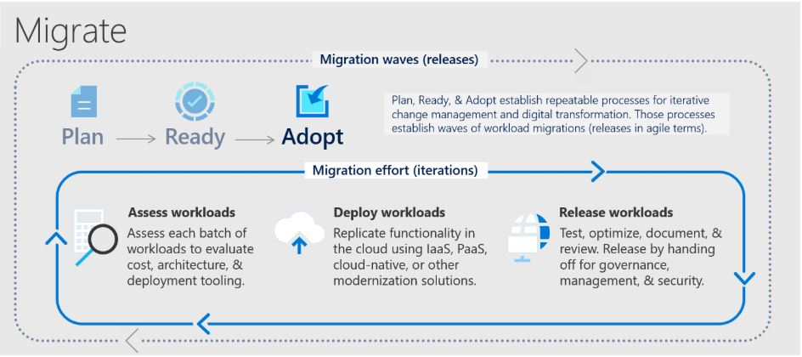

Assessment
Identify existing data sources and details about the features that are being used to get a better understanding of and plan for the migration. First Step is to scan the network to identify all your organization’s SQL instances together with the version and features in use. MAP Toolkit does not require an agent. It automatically inventories the devices, software, users and infrastructure in a Windows or Windows Server deployment and produces a readiness report and proposal for executives with hardware and software information. The data can include metrics such as the number of devices, how many devices run Windows and the number of users. The readiness report can also include information on the applications users work with and if those applications are compatible with the desktop or server operating system IT plans to move to.

When your landing zone for your SQL server data is a Azure SQL Managed Instance and the data sources have been identified, the next step is to assess on-premises SQL Server instance(s) migrating to Azure SQL Managed Instance to understand the gaps between the source and target instances. To assess the workload native as well as third party assessment tools are as follows:
Assessment Tools | Features | Unique Benefits
Database Migration Assistant | Data Migration Assistant helps pinpoint potential problems blocking migration. It identifies unsupported features, new features that can benefit you after migration, and the right path for database migration. | DMA is able to discover issues that not only disrupt the migration process, but also those that disrupt the on-premises upgrade process for SQL Server. DMA can also discover the new features that are present in the target SQL platform, and will prove to be beneficial for the database, once the upgrade is done.
Azure Migrate: Server Assessment | Discover and assess on-premises VMware VMs, Hyper-V VMs, and physical servers in preparation for migration to Azure. | It can perform assessment in two ways:  - Assessment based on collected performance data  - Assessment based on on-premises sizing
Unifycloud  (CloudRecon) | CloudRecon creates a cloud migration strategy and assessment by conducting a deep scan on your IT infrastructure, producing recommendations on which applications should migrate to the Cloud (SaaS, IaaS, or PaaS), and the roadmap behind it. CloudRecon is capable of providing TCO estimates and can validate the move to the cloud. | Automated on-premises infrastructure assessments in minutes, not months.  Automation saves time and expense over arduous manual assessments.  Detailed inventory assessments provide insights to inform your cloud migration strategy.
Cloudamize | Cloudamize is a cloud computing analytics platform that provides high precision analytics and powerful automation to improve the ease, speed, and accuracy of moving to the cloud. | Cloudamize’s discovery, integrated compatibility reporting, right-sizing, and performance and cost predictions enable customers to understand where SQL updates are required and whether it’s better from a cost-performance optimization standpoint to take the IaaS or PaaS version of SQL migration.

An overview of the steps associated with using DMA to create an assessment follows.
- Open the Data Migration Assistant (DMA), and then begin creating a new assessment project.
- Specify a project name, select SQL Server as the source server type, and then select Azure SQL Managed Instance as the target server type.
- Select the type(s) of assessment reports (database compatibility and feature parity) that you want to generate.
- The SQL Server feature parity category provides a comprehensive set of recommendations, alternative approaches available in Azure, and mitigating steps to help you plan the effort into your migration projects.
- The Compatibility issues category identifies partially supported or unsupported features that reflect compatibility issues that might block migrating on-premises SQL Server database(s) to an Azure SQL managed instance. Recommendations are also provided to help you address those issues.
- Specify the source connection details for your SQL Server, connect to the source database, and then start the assessment.
- When the process is complete, review the assessment reports for migration blocking issues and feature parity issues by selecting the specific options.
- Determine the database compatibility level that you want to minimize your efforts after migrating to Azure SQL.
- Identify the best Azure SQL Database managed instance SKU for your on-premises workload.

For additional detail on this process, see the article Perform a SQL Server migration assessment with Data Migration Assistant. There are also additional target decisions that you will have to make before starting migration phase. Some things worth taking into consideration are:
- In which region you want your target Azure SQL server
- How much downtime is acceptable for your business needs?
We provide more details in the following segments.

Region
Azure SQL Managed Instance can be created in multiple regions around the globe. The below diagram shows the regions available in North America.
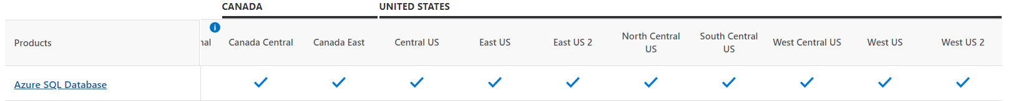
It's recommended to keep the on-premises source and Azure target in the same region to keep latency low and increase the performance during migration. Example: If you have on-prem server in East US, then choose Azure SQL MI Service in US East Region.
For High Availability (HA) of Azure SQL MI, multi-region deployment is one of the techniques which uses Azure Traffic Manager to failover if the DB fails in one region.
In such a scenario, combined SLA for multiple regions can be calculated as follows.

Let N be the SLA for SQL Database in one region and R be the number of regions where SQL Database is deployed. Combined SLA can be given as = 1 - (Product of Downtime of every region)

Let’s say N = 99.95% for all regions. so the downtime for all regions will be 0.05%
Combined SLA for 2 regions = (1 - (0.0005 ^ 2)) = 99.999975%
Combined SLA for 4 regions = (1 - (0.0005 ^ 2)) = 99.999999%
So, when we have more regions Combined SLA will increase. Below are the combination of Azure SQL DB deployments option and their promised SLAs.
SLA | Tier | Requirements
99.995% | Business Critical + Premium | Zone Redundant Deployment
99.99% | Business Critical + Premium | N/A
99.99% | General Purpose, Standard, Basic, Hyperscale | 2 or more replicas
99.99% | Hyperscale | 0 replicas

Consider checking Latency before performing multi-region deployment using below links:
- https://cloudpingtest.com/azure
- https://www.azurespeed.com/Azure/Latency

Migration Toolset
There are two primary methods to migrate from an on-premises SQL Server to Azure SQL Database managed instance. The recommended method for large enterprise databases is to use the Azure Database Migration service, since it can minimize downtime and have a free availability-tier. Furthermore, if quick, no cost, off-line data migration is preferred; migration can be carried by using the ‘Native RESTORE from URL’ method.
Migration Option | Key Features
Azure Database Migration Service | - Minimal downtime during migration  - Offers online and offline options  - If SQL Server Integration Services (SSIS) is used, this service cannot replicate your packages. However, you can Azure-SSIS in a managed instance. For more information click here
Native RESTORE from URL | - Offline method which requires downtime  - Available for all versions of SQL Server
Unifycloud (CloudPilot) | - Demonstrate how the cloud can lower the cost.  - Reduce the time and expense to migrate applications to the Cloud.  - Create a standard approach to developing and remediating applications to run in the Cloud.  - Provide a standard Cloud controls environment for both development and deployment testing.  - Simple App Data Collection  - Cloud Migration Refinement
Cloudamize | - Move workloads to Azure with speed and accuracy and ensure cost-performance optimization now applications migrate.
Transactional Replication | - Critical database with small or non-existent maintenance window  - Large databases (>1TB)

For a walkthrough of the phases of the migration process and detail about the specific tools and services recommended to perform assessment and migration, see the video Overview of the migration journey and the tools/services recommended for performing assessment and migration.

Azure Database Migration Service gives you the option of migrating offline and online. With offline migration, your application downtime will last for the duration of the migration. On the other hand, with online migration your downtime will be limited to the time to cut over at the end of the migration.

Deployment
This section will specifically discuss the following.
- Azure Migration Service
- Native RESTORE from URL

Azure Migration Service
Once decision is made to go with the Azure Migration Service as migration method, there is an option of using the standard tier or the premier tier. This is very similar to the process described in the Deployment – Azure SQL Database section. To do the migration, one of the following links can be used:
- Online: https://docs.microsoft.com/en-us/azure/dms/tutorial-sql-server-managed-instance-online
- Offline: https://docs.microsoft.com/en-us/azure/dms/tutorial-sql-server-to-managed-instance

Native RESTORE from URL
The migration process for getting databases to Managed Instance via Backup and Restore is very similar to how we currently move databases between SQL Servers. At the most basic level it is a backup to a shared storage location, then a restore from there to the target system. However, there is one key stipulation, that storage location is Azure Blob Storage. This key capability of managed instance deployment enables quick and easy offline database migration.
The following diagram provides the high-level overview of the process.
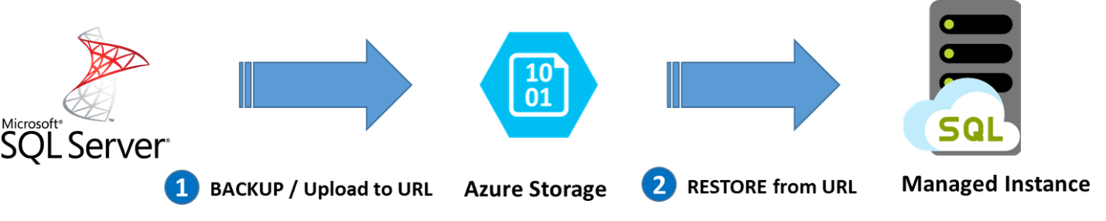

- Step 1 is to complete a SQL Server backup to Azure Blob Storage,
- Step 2 is then simply a case of restoring the database from the backup that is in Azure Blob Storage.
Prerequisites:
- The On-premises SQL databases need to have service broker enabled, because it is on by default for databases hosted on Managed Instance.
- Prior to performing Step 1 of taking the database backups, it is important to configure the Azure Blob Storage so that we can store the backups there.
To configure Azure Blob Storage:
- Create Storage Account and Blob Container
- Define Access Policy
- Generate Credential Statements (creating T-SQL for SQL server credentials)

STEP 1
There are different methods of backing up On-premises SQL Database for different SQL version as follows:
Operation | SQL Engine and version | Backup / Restore method
Put backup to Azure Storage | Prior SQL 2012 SP1 CU2 | Upload .bak file directly to Azure storage
 | 2012 SP1 CU2 - 2016 | Direct backup using deprecated WITH CREDENTIAL syntax
 | 2016 and above | Direct backup using WITH SAS CREDENTIAL

- Pre-SQL Server 2012 CU2: If migrating from a version of SQL server that is prior to SQL Server 2012 CU2 then there is need to backup locally and then copy the files to Azure Blob Storage. The easiest way to complete this task is to make use of PowerShell and the DBATools module. By doing this we can complete the SQL Server backup, and push to blob storage all with one easy script in PowerShell. In script we will define the local storage location to complete initial backup and then copying files to azure blob. Finally, generated restore commands will be used to restore the DB to managed instance.
- SQL Server 2012 CU2 to 2016: SQL Server 2012 introduces the capability to perform a native backup directly to URL with a T-SQL Statement. In order to facilitate this, we first need to create a Credential object that we will specify as part of the backup command. In order to create the SQL Server Credential, we will need the name of the Azure Storage Account that we created earlier, as well as the key. This will then allow SQL Server to access the storage account to store the backup files in the Storage Account. Credentials can be created using T-SQL or DBATools in PowerShell. Once the Credential has been Created, we are able to take the database backup directly to URL. This is very similar to a normal BACKUP DATABASE command, however, in this case, we need to use URL in place of FILE and specify the Credential we created a moment ago. Backing up database can be done using T-SQL or DBATools in PowerShell.
- SQL Server 2016 and above: SQL Server 2014 and higher can natively backup to URL much like SQL Server 2012. However, with SQL Server 2014 the format for the CREATE CREDENTIAL statement changed. It no longer needs the Storage Account Name and key. In place of this, the name of the Credential needs to be the path to the container, and the SAS Token for the account needs to be supplied. Credentials can be created using T-SQL or DBATools in PowerShell. Once the Credential has been created, we are able to take the database backup directly to URL. we need to use URL in place of FILE and specify the Credential we created a moment ago.Backing up database can be done using T-SQL or DBATools in PowerShell.

STEP 2
With the backups in place, it is now possible to restore them on to the Azure SQL Database Managed Instance. The Managed Instance will handle the distribution and location of the database and log files on available storage. Before it is possible to restore the database(s) a credential needs to be created that will allow access to the Azure Blob Storage for the backup files. This credential uses the same syntax as that for SQL Server 2016 and above. After creating a credential with T-SQL we can use basic RESTORE DATABASE command to restore DB in Managed Instance.

With the databases now restored it is a simple case of making the changes to the applications that need to connect to the database. It is also important to remember the connectivity options for Managed Instance, it is only accessible via the v-Net that it has been deployed to. Once the database has been migrated then you will need to migrate server scoped entities such as logins, linked servers, credentials, etc. that are needed for the functioning of the database in the context of its solution.

Release
This section will specifically discuss about the Release phase

Overview
After you have completed migrating, you’re on-premises server into Azure, you need to ensure that the source data is accurately reflected in your new environment. As well as making sure that functionality has been correctly adjusted.

Migration Testing:
There are various technologies that can help you when comparing your source and target database data objects.
The test approach for database migration consists of performing the following activities:
- Develop Validation Tests: To test database migration, you need to use SQL queries. you need to use SQL queries. You must query to run against both the source and target databases.
- Set up test environment: The test environment should contain a copy of the source database and target database. Be sure to isolate the test environment.
- Run Validation tests: Run the validation tests against the source and target, and then analyze the result.
- Run performance tests: Run performance test against the source and the target, and then analyze and compare the results.

In the following sections, we’ll provide specific tools and how to use them to perform migration testing.
- Optimization: Beyond addressing data incompleteness and accuracy, it is necessary to uncover and remediate any performance issues from each workload. As part of this document, we’ll cover some common performance issues that occur from SQL server to SQL server migration and how to address them properly.
- Remediate applications: All client applications which rely on the database must make the correct adjustments to begin consuming data from the newly constructed database. Depending on what are the client applications, the adjustments could be vastly different.

Migration Testing
The objective during the testing phase should be to assess data accuracy in the target database, find incomplete records, and improve performance efficiency. To accomplish this, you could a data comparison tool such as SQL Server Data Tools to perform your data comparison, which we’ll provide details of how to use in the following section.
Additionally, you may have specific data comparison needs that other tools might be more suited for. For that, we have provided some third-party applications which you may look into when choosing your data comparison tool.

SQL Server Data Tools for Visual Studio:
A great tool to use anytime when you would like to compare 2 databases, their table schemas, views, and table records is SQL Server Data Tools (SSDT) for Visual Studio. Depending on your Visual Studio version, you may already have this configured or may need to add it as an extension. To find more information about your Visual Studio installation and SSDT availability, please read the following article from Microsoft’s documentation:
https://docs.microsoft.com/en-us/sql/ssdt/download-sql-server-data-tools-ssdt?view=sql-server-ver15
After you have SSDT set up in your environment, you are ready to begin comparing your databases.
Comparing Databases:
- Open Microsoft Visual Studio.
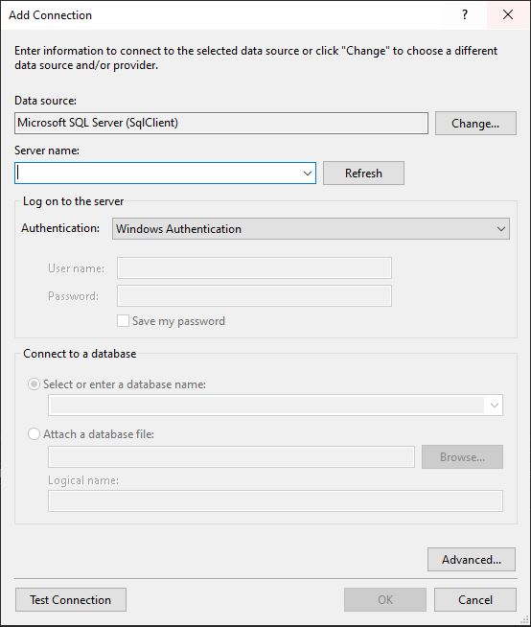
- Under the ‘Tools’ tab in the toolbar menu, select ‘Connect to Server…’.
- Enter the name or the IP address of the machine with your database.
- Under the ‘Tools’ tab in the toolbar menu, select ‘Connect to Database…’. This should display a window such as this:
- Select ‘Microsoft SQL Server (SqlClient)’ as your data source.
- Select the name of your database server which you added in step 3
- If you are working on the same machine from which you are establishing the connection to and you have administrative rights, you may use ‘Windows Authentication’. Otherwise choose ‘SQL Server Authentication’ and provide credentials with administrative rights.
- Select the database you would like to test.
- Test your connection and Press ‘OK’ if your connection worked, otherwise troubleshoot accordingly.
- Repeat steps 2 – 9 for the target database.
At this point you should have created connections to both servers and should be ready to start comparing the two databases.
- Under the ‘Tools’ tab, go to ‘SQL Server’ and select ‘New Data Comparison’.
- This should prompt a window like this:
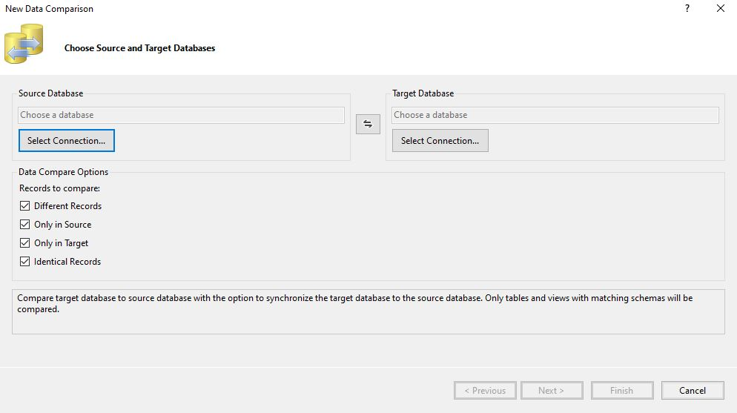
- Select your source connection and target connection respectively by
- Clicking on the ‘Select Connection…’.
- Click ‘Next’ and then select the SQL object you would like to take into consideration during your comparison.
- Click ‘Finish’.
Once SSDT has completed executing the comparison, you should have a view like the following:

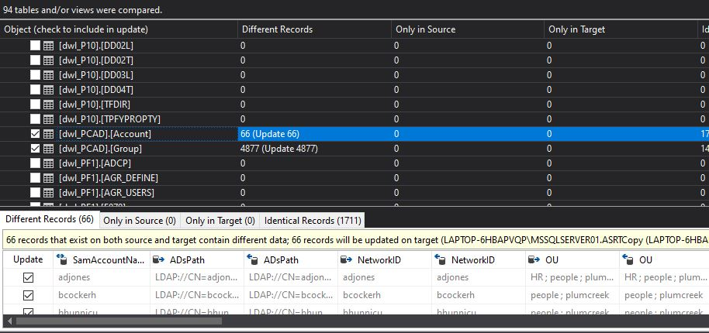

From analyzing this result, you should be able to derive data inconsistencies and accuracy. The following section will cover how you can synchronize your data to eliminate these inconsistencies.
Data Synchronization:
After you’re done inspecting the records which are missing at the target database, you can synchronize those records by using the details pane:

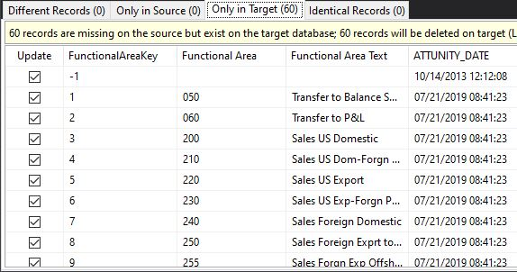

Every record which needs to be synchronized should be selected in the ‘Update’ column on the left-hand side. Depending on the size of the T-SQL file you can either click ‘Generate Script…’ or from the toolbar menu under ‘SQL’, select ‘Export to File…’.
Since we are only trying to migrate records from the source to the target and not the other way around, you should only select records in the ‘Only in Source’ tab. Additionally, the T-SQL script that SSDT creates will delete the records from the source database; if you wish to avoid deleting records from the source database at this point, you can remove any DELETE statement from the script.

Other Data Comparison Tools:
There are other tools that you might want to check out if SQL Server Data Tools does not have a feature you would like to use during your migration assessment. Some third-party tools that you can look further into are included in the following chart.
Product Name | Operating System | Data Synchronization | Schema Compare | Schema Sync | Free Tier Availability
QuerySurge | Windows | Yes | Yes | Yes | No
Red Gate SQL Compare | Windows | Yes | No | No | No
SQL Data Examiner | Windows | Yes | No | No | No
dbForge Data Compare for SQL Server | Windows | Yes | No | No | No
DB Ghost Change Manage Professional | Windows | Yes | Yes | Yes | No
MssqlMerge | Windows | Yes | Yes | Yes | Yes

Optimization
Beyond assessing data accuracy and completeness, you should find any underlying performance issues that might have spawn from your migration. Optimization might include the following steps:
- Assess what new features may be available on the target platform: New features that were previously too complex or cost inhibitive to warrant implementation on-premise may now be available via a few clicks in the Azure Portal. These features should be considered as to whether they would bring good benefits to each workload and then should be implemented as appropriate.
- Re-structure workloads into more cost effective or performance effective sets: This might include allocating databases that make up a workload into various service levels and performance tiers on Azure SQL Database. These were previously lumped together on the same on-premises SQL Server due to hardware and licensing costs, but with the fully managed service offering of Azure SQL Database it’s now cost effective to grant individual databases additional resources if beneficial.
- Ensure workloads are right-sized: Look to realign workloads into the more appropriate service levels and performance tiers. Previously they shared a combined pool of compute and storage resources on the physical server where they resided that was underutilized to allow for future growth. Now with the fully managed service offering of Azure SQL Database it’s possible to get a more accurate size of the databases by using tools such as the Azure SQL Database DTU calculator or comparing on-premises core requirements to vCores and dial up the allocated resources only if required.

Below is some recommendation for best performance during the migration process:
- Choose the highest service level and performance tier that your budget allows for the migration time to maximize the transfer performance: While migrating, the database will be performing an enormous quantity of write operations and by under-sizing the selected performance tier you may unintentionally throttle the throughput, causing a much-extended migration timeline. Instead, choose a higher performance tier than needed temporarily during the migration, and then scale back down after the migration to minimize costs.
- Disable auto-statistics during migration: On Azure SQL Database, statistics objects have “Auto update” turned on by default. The auto update of the statistics is done when a enough change to a table has occurred. During the import process, when nearly all the rows in all tables are changing, this trigger is repeatedly met, causing continuous attempts to update the statistics. This update uses valuable IO resources to complete, which detracts from the overall pool of IO resources available for the import process and extends the migration timeline.
- Partition tables and indexes: Partitioning tables and indexes can help with the transfer and access of data during a migration. The data can be partitioned into one or more subsets that are similar and will allow for the transfer of data quicker. Partitioning large datasets can also reduce lock contention, because lock escalation can be activated at the partition level without hurting the entire dataset. Once the data is moved to the cloud, then queries may performance faster and reduce overhead costs for applications. Overall partitioning tables and indexes helps the migration cost and mitigates future risk after the migration by helping increase performance of the data.
- Drop indexed views and recreate them once finished: When an indexed view is used, every time data is modified on an underlying table Azure SQL maintains the index entries on those tables, but also the index entries on the view. This can affect write performance and again reduce IO resources available for the import process, extending the migration timeline. In addition, they also have the potential to cause other issues such as lock contentions.
- Remove rarely queried historical data to another database and migrate this historical data to a separate Azure SQL Database. You can then query this historical data using elastic queries: By purging historical data from a database, the size of the database and thus the amount of data needing to be migrated can be drastically reduced. This helps meet tight maintenance window targets as the core data can be moved to Azure SQL in a much shorter time, enabling the application to be brought back online sooner. The rarely queried historical data can be migrated in a less aggressive timeframe given it is a much lower priority.

Below section will cover some common performance issues and how you can debug them.

Query Regressions due to change in CE Version
If you have migrated from a SQL Server version older than 2014 and you have adjusted your database compatibility level to the latest version, there is a high risk that you’ll have performance regression. This is because since SQL Server 2014, all Query Optimizer changes are correlated with the latest database compatibility level. The purpose of this change was to give database users greater control over query performance when performing an upgrade.
You can learn more about this in the following document:
https://docs.microsoft.com/en-us/previousversions/dn673537(v=msdn.10)?redirectedfrom=MSDN

Solution
To resolve this issue, you should first change your database compatibility level back to the source database version and then you can follow the following steps to optimize your query performance:
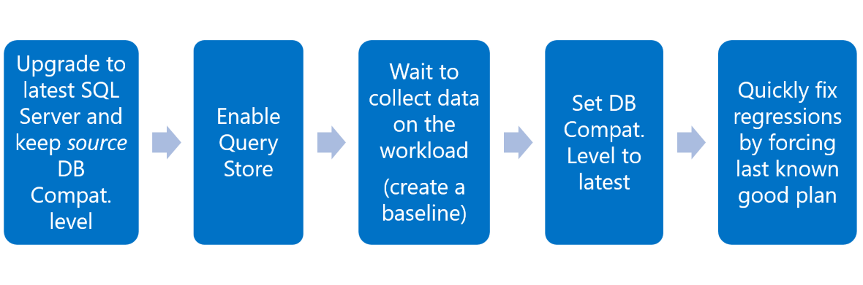
Missing Indexes
When executing queries, stored procedures, and views; SQL performs caching to speed up performance any time the same action is recalled. In the migrated database, this caching of execution plans will not be available at first and will cause execution delays. To minimize this impact, you can follow these steps:
- Use the RECOMPILE hint. A plan is calculated every time adapted to each parameter value.
- Edit your stored procedures to use (OPTIMIZE FOR(<input parameter> = <value>)). Depending on the workload, you will have to choose a value for creating and maintaining one plan that becomes efficient for parameterized values.
- Rewrite the stored procedure using local variable inside the procedure. Now the optimizer uses the density vector for estimations, resulting in the same plan regardless of the parameter value.
- Alternatively, you can edit your stored procedures to use (OPTIMIZE FOR UNKNOWN), which would have the same outcome as using the local variable technique.
- Rewrite your queries to use “DISABLE_PARAMETER_SNIFFING”. This would also have the same effect as using the local variable technique, unless “OPTION(RECOMPILE)”, “WITH RECOMPILE”, or “OPTIMIZE FOR <value>” are used.

Additional Post Migration Validation and Optimization Documents
For additional detail about these issues and specific steps to mitigate them, see the following resources:
- The Post-migration Validation and Optimization Guide.

Additional Resources
Following are details of Additional Resources:
- SQL migration using Azure Data Migration Service (DMS) hands-on lab.
- Be sure to check out the Azure Total Cost of Ownership (TCO) Calculator to help estimate the cost savings you can realize by migrating your workloads to Azure.
- For a matrix of the Microsoft and third-party services and tools that are available to assist you with various database and data migration scenarios as well as specialty tasks, see the article Service and tools for data migration.
- For options related to migrating Azure SQL Database to a managed instance, see the blog post How to Migrate Azure SQL Database to Azure SQL Managed Instance.
Videos
- For an overview of the Azure Database Migration Guide and the information it contains, see the video How to Use the Database Migration Guide.
- For a walkthrough of the phases of the migration process and detail about the specific tools and services recommended to perform assessment and migration, see the video Overview of the migration journey and the tools/services recommended for performing assessment and migration.
- For details about the pre-requirements, including Azure VNet and firewall setup, needed to create a DMS instance, see the video How to address pre-requisites and create an instance of the Azure Database Migration Service.
- For information about how to monitor an online migration and perform a migration cutover when the initial load and data sync have completed, see the video How to monitor an online migration and perform migration cutover.

